PocketSmart AI – Smart Budget & Recommendation.

Project Description:
PocketSmart AI is a web-based personal finance assistant that helps users record income and expenses, set a monthly budget, understand spending patterns, and receive practical recommendations. It is designed for students, first-job earners, and small-budget households that need a simple way to build better financial habits.

Project Identity:
Date: 03 October 2026

Team ID: SWTID-2026-7684
Project Title: PocketSmart AI – Smart Budget & Recommendation Assistant

GitHub Repository: https://github.com/aparnamunusamy2006-commits/PocketSmart-AI
Demo Video: https://drive.google.com/file/d/1PPGwu4jDFyQ23oKEMC1cMWpFv3fIqrT-/view?usp=drivesdk

PocketSmart AI combines a React.js + Vite frontend, a Python Flask REST backend, SQLAlchemy data models, JWT authentication, and Google Gemini AI. PostgreSQL is.
Scenarios

Technical Architecture:

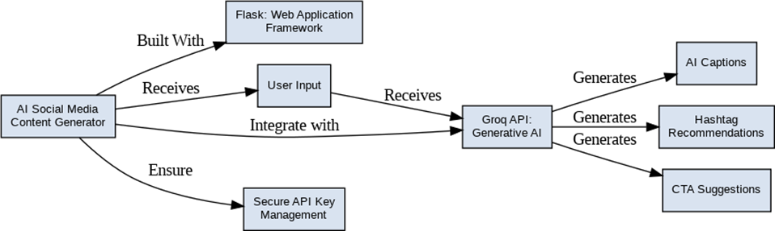

Scenario 1: A new.
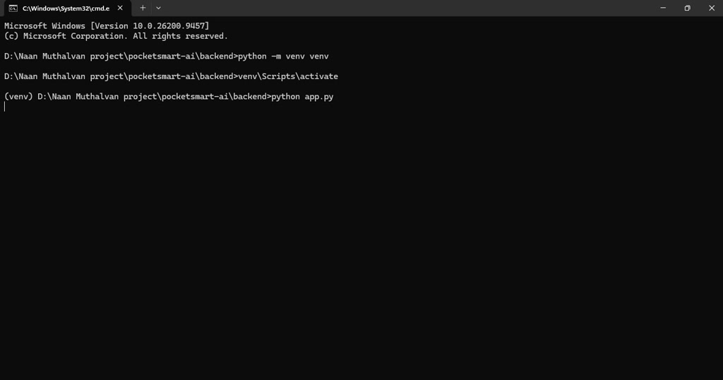
Scenario 2: The user enters a monthly budget and records income or expenses such as salary, food, rent, transport, shopping, bills, health, education, and entertainment. Each transaction stores its type, amount, category, note, and date.

Scenario 3: The dashboard calculates the current month’s total income, total expense,.

Scenario 4: The.
- Scenario 5: The user opens the Gemini.
- Scenario 6: The user asks the finance chatbot a question. The chatbot combines the question.
- Technical Architecture:
- Figure 1 – PocketSmart AI dashboard with.
- Figure 2 – PocketSmart AI monthly.
- Description: PocketSmart AI uses a modular.
- Presentation Layer: React.js, React DOM, Vite, and CSS provide the browser.

Application.

Data Layer: User records contain.
- AI Layer: gemini_service.py uses the Google GenAI SDK and the gemini-2.5-flash.
- Entity Relationship Description:
- The User entity has a one-to-many relationship with Transaction. One user can own many transactions, while.
- Pre-requisites:

Python 3.x and pip for the Flask.
- Node.js and npm for the React + Vite frontend.
- Git for cloning and version control.

A modern web browser.
- A Google Gemini API key for AI analysis, recommendations, and chatbot functions. The dashboard and.

Optional PostgreSQL.
- Project Workflow:
- Milestone 1: Repository, environment, and architecture setup.

Activity 1.1:.
- Activity 1.2: Create a Python virtual environment and install the pinned Flask, CORS, SQLAlchemy, JWT, dotenv, and Google.
- Activity 1.3: Create backend/.env from example.env and configure GEMINI_API_KEY, JWT_SECRET_KEY, and an.

Activity 1.4:.

Milestone 2: Authentication and data.
Activity 2.1: Implement registration with name, email, password validation, password hashing, and duplicate-email protection.

Activity 2.2: Implement login with.
Activity 2.3: Define User and Transaction SQLAlchemy models and create the database tables at application startup.
- Milestone 3: Core personal finance features.

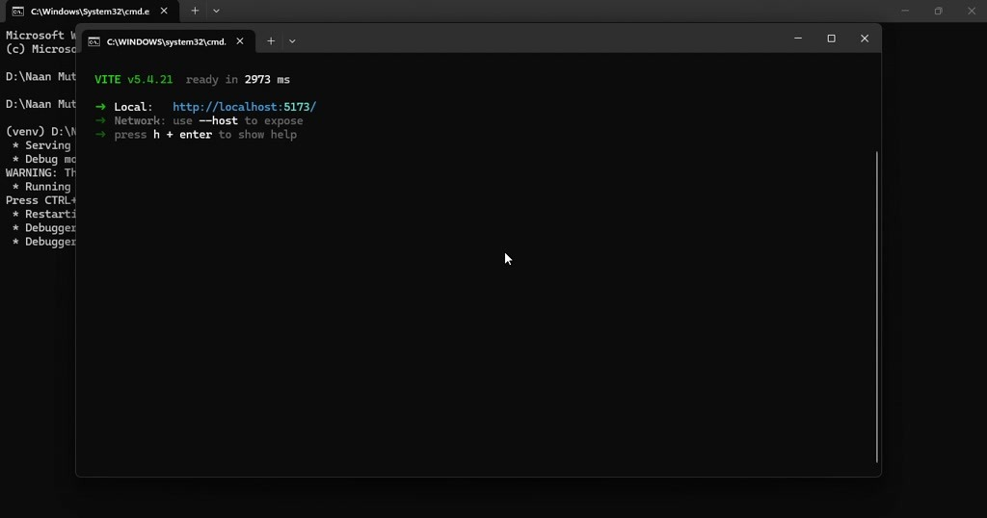
- Activity 3.1: Implement monthly budget updates and user profile retrieval.

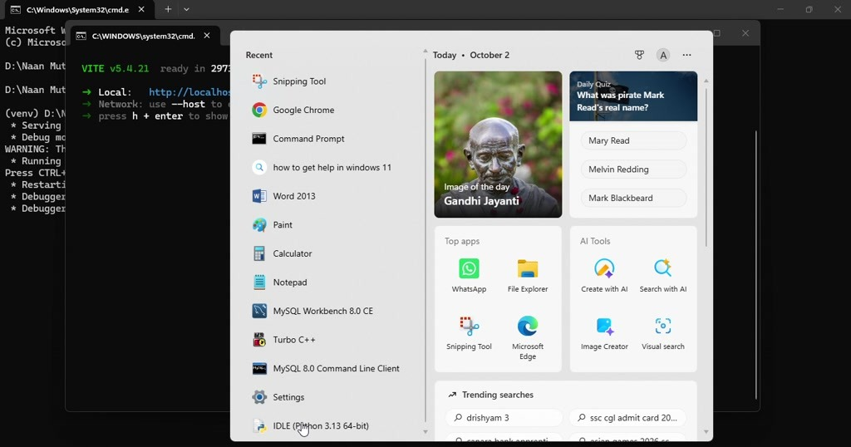
- Activity 3.2: Implement authenticated transaction creation, listing, validation, and deletion.

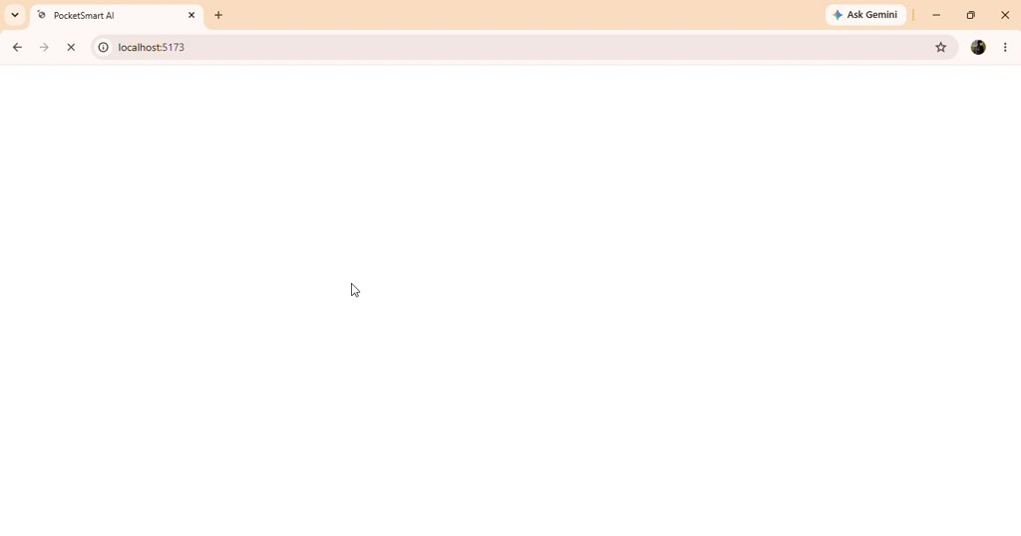
- Activity 3.3: Implement monthly income, expense, savings, budget percentage, and category aggregation.

- Activity 3.4: Implement rule-based tips for low savings, budget overrun, budget usage above 80 percent, and high category concentration.
- Milestone 4: React frontend development.
Activity 4.1: Build the Auth.
Activity 4.2: Build the Dashboard component with.
- Activity 4.3: Build the AiPanel component with buttons for budget analysis and recommendations.
Activity 4.4:.

Milestone 5: Gemini AI integration.
Activity 5.1: Create a friendly personal-finance system prompt with.
  - Activity 5.2: Implement analyze_prompt for three key insights, the biggest problem area, and a suggested budget split.
  - Activity 5.3: Implement recommend_prompt for saving tips and beginner-friendly options such as SIP, RD, FD, and an emergency fund.
  - Activity 5.4: Implement chat_prompt to answer a user question using the current monthly snapshot.
  - Milestone 6: Demonstration, testing, and documentation.

Activity 6.1: Run the backend and frontend.
  - Activity 6.2: Demonstrate registration, login, budget setup, transaction entry, dashboard summaries, category analysis, AI insights, recommendations, and chatbot interaction.
  - Activity 6.3: Record the demo video and capture representative screens for this documentation.
  - Activity 6.4: Document limitations, setup instructions, API routes, architecture, and future improvements.
  - Backend API Summary:

POST /api/auth/register – validates.
  - POST /api/auth/login – verifies credentials and returns a JWT token and user data.
  - GET /api/me – returns the authenticated user profile.
GET /api/transactions – lists the authenticated user’s.
POST /api/transactions – validates and.
  - POST /api/ai/analyze – sends the.
POST /api/ai/chat – sends a user.
  - backend/app.py – Flask application, routes, validation, authentication, budget,.
  - backend/models.py – SQLAlchemy User and Transaction models.
backend/requirements.txt – Python.
  - frontend/src/App.jsx – main application state and authenticated view routing.
frontend/src/api.js – shared.
  - frontend/src/components/Auth.jsx – login and registration UI.
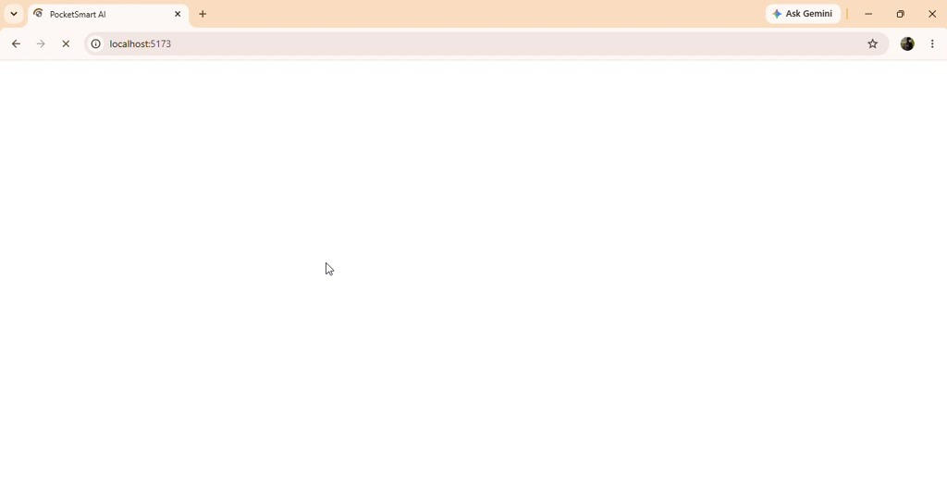

frontend/src/components/Dashboard.jsx.

frontend/src/components/AiPanel.jsx –.
frontend/src/components/Chatbot.jsx – finance chatbot UI.
  - frontend/src/styles.css – application styling.
  - Setup Instructions:
  - Backend terminal: cd backend

Create and activate a virtual.

Install.
- Copy example.env to .env and add GEMINI_API_KEY. Set a.

Run the backend.
- Frontend terminal: cd frontend, run npm install, and then npm run dev. Open the local Vite URL.
- PostgreSQL Configuration:
- Create a database named pocketsmart and set.

AI Prompt and Safety Design:
- Gemini receives a structured summary rather than unrestricted database access. The system prompt asks for short, practical, beginner-friendly advice and identifies INR.
- Validation and Error Handling:
- Registration requires a name, email, and password with at least six characters. Duplicate emails return a conflict response. Login.

Demo Video Evidence:
Figure 3 – Gemini AI Insights panel with PocketSmart AI recommendation output.

Figure 4 – PocketSmart AI Finance Chatbot.

The supplied demo video.
- Functional Features:
  - 1. User registration and login with JWT authentication.

  - 2. Password hashing using Werkzeug security helpers.

4. Income and.
5. Transaction listing and deletion.
6. Monthly.
7. Budget-used percentage and progress visualization.
8. Category-wise spending.
9. Rule-based financial tips.
10..
11..
12. Gemini-powered finance chatbot.
Testing and Verification:
Functional smoke testing.
The demo video provides visual evidence of the.

Project identity: Date 03.
- The application is designed for students, first-job earners, and small-budget households that need a simple personal-finance workflow.
- Users can register, sign in securely, set a monthly budget, add income and.
- Income and expense records contain amount, category, note, date, and transaction type. Categories include salary, food, rent,.

The dashboard shows.
- PocketSmart AI keeps each user’s data scoped to the authenticated account by using JWT-protected routes and user_id.

The budget.
The summary logic groups expense transactions by category and returns totals that are rendered as horizontal.
Rule-based tips identify low savings, budget overrun, high budget usage, and a dominant expense.
The AI analysis endpoint sends the monthly summary to Gemini and asks for key observations, the main.
The.

api.js adds the.
The backend is divided into app.py for routes, models.py for database entities, and gemini_service.py for Gemini.
Flask-CORS allows the React development server to call the backend during local development.
SQLAlchemy uses.

Frontend start command: npm run dev.
Local backend URL: http://localhost:5000.

Local frontend URL: the Vite URL shown by npm run dev,.

Demo evidence image 01: terminal used to.
- Demo evidence image 02: terminal command used to start or inspect the backend project.
Demo evidence image 04:.
Demo evidence image 05: backend source or command-line development step from.
Demo evidence.
Demo evidence image 07: browser launch and.
Demo evidence.
Demo evidence image 09:.
Demo evidence image 10: transaction and category view.
Demo evidence.
Demo evidence image 12: Gemini recommendation view with.
Demo evidence.
Demo evidence image 14: Finance Chatbot.
Demo evidence.
The CMD/terminal screenshots are included as.
No personal API.
Future improvements include recurring.

- SQLite is used for quick local evaluation and PostgreSQL is supported for deployment.
- The browser evidence confirms the dashboard, AI Insights, and Chatbot flows.
The terminal evidence confirms the local backend and.

Category totals help the.
Budget progress makes monthly spending easier to understand.

The project separates UI components, API.

PocketSmart AI validates.
- The React dashboard refreshes the summary after a transaction is created.
- JWT protection keeps finance data available only to the signed-in user.
- Gemini responses are displayed in readable beginner-friendly language.

SQLite is used for quick.
- The browser evidence confirms the dashboard, AI Insights, and Chatbot flows.
- The terminal evidence confirms the local backend and frontend development workflow.
- Category totals help the user identify the largest spending area.

Budget progress makes monthly spending.
- The project separates UI components, API helpers, Flask routes, models, and AI prompts.
- PocketSmart AI validates user input before saving finance records.
- The React dashboard refreshes the summary after a transaction is created.

JWT protection keeps finance data available only to.

Gemini responses are displayed.
- SQLite is used for quick local evaluation and PostgreSQL is supported for deployment.
- The browser evidence confirms the dashboard, AI Insights, and Chatbot flows.

The terminal.
- Category totals help the user identify the largest spending area.
- Budget progress makes monthly spending easier to understand.

The project separates UI.
- PocketSmart AI validates user input before saving finance records.

The React.
JWT protection keeps finance data available only to the signed-in user.

Gemini responses are displayed in readable.

SQLite is used for.
- The browser.
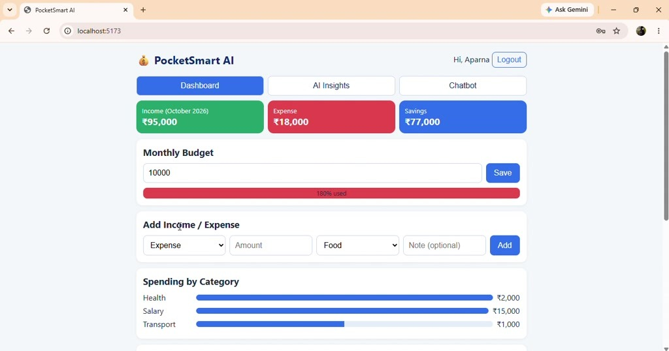
- The terminal.
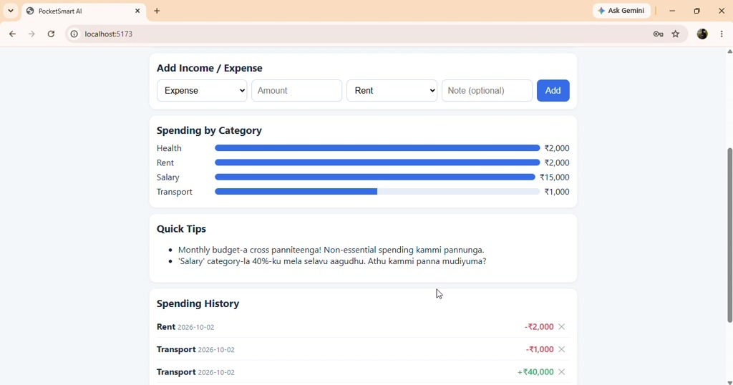

- Category totals help the user identify the largest spending area.
The project separates UI components, API helpers, Flask routes, models, and AI prompts.

The React dashboard.
- JWT protection keeps finance data available only to the signed-in user.
Gemini responses are.

SQLite is used for quick local.

The browser evidence.
- The terminal evidence.
Budget progress makes.
- PocketSmart AI validates user input before saving finance records.
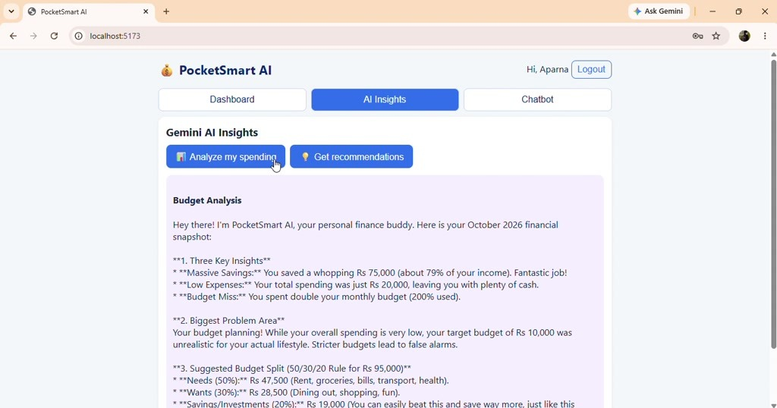
- The React dashboard refreshes the summary after a transaction is created.

JWT protection keeps finance data available.
Gemini responses are displayed in readable beginner-friendly language.

SQLite is used for quick local.
- The browser evidence confirms the dashboard, AI Insights, and Chatbot flows.
Category totals help the.
- The project separates UI components, API helpers, Flask routes, models, and AI prompts.
- PocketSmart AI validates user.
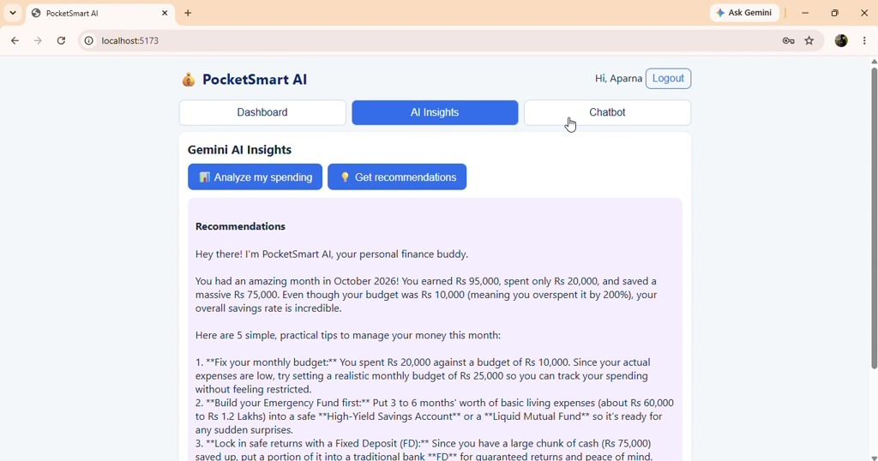

The React dashboard refreshes the.
- JWT protection keeps finance data available only to the signed-in user.
- Gemini responses are displayed in readable.
The browser evidence confirms the dashboard,.
- Category totals help the user identify the largest spending area.

Budget progress makes.
- The project separates UI components, API helpers, Flask routes, models, and AI prompts.
- PocketSmart AI validates user input before saving finance records.
The React dashboard refreshes the summary after a transaction is created.
JWT protection keeps finance data available only to the signed-in user.
Gemini responses are displayed in readable.

- SQLite is used for quick local evaluation and PostgreSQL is supported for deployment.

The browser.
- The terminal evidence confirms the local backend and frontend development workflow.
- Category totals help the user identify the largest spending area.
- Budget progress makes monthly spending easier to understand.

The project separates UI.

PocketSmart AI.
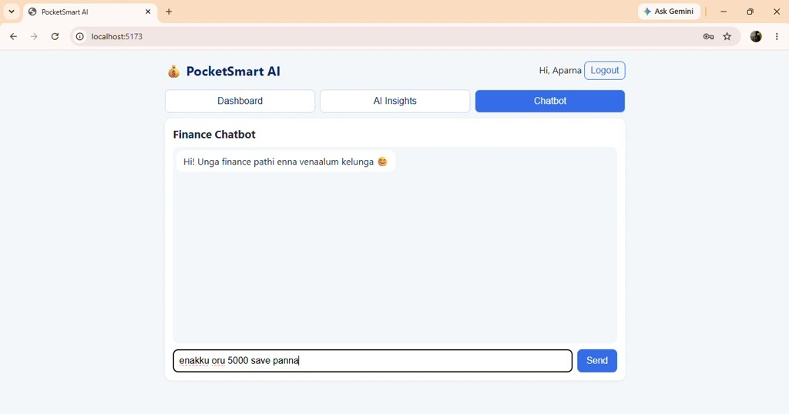
The React dashboard refreshes the summary after a transaction is created.

JWT protection.
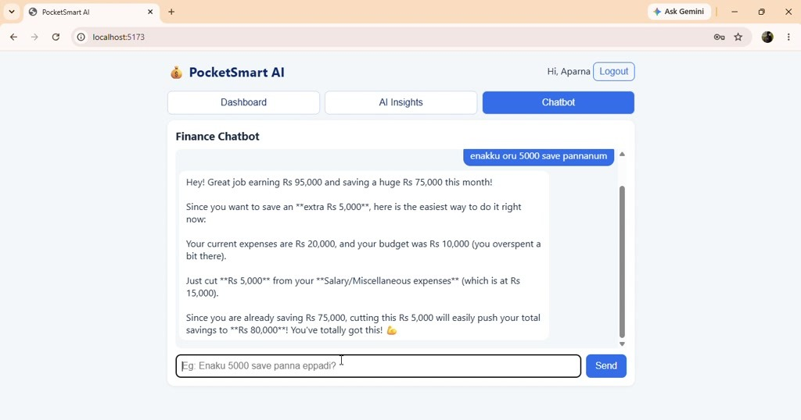
Gemini responses are displayed in readable beginner-friendly language.

SQLite is used.
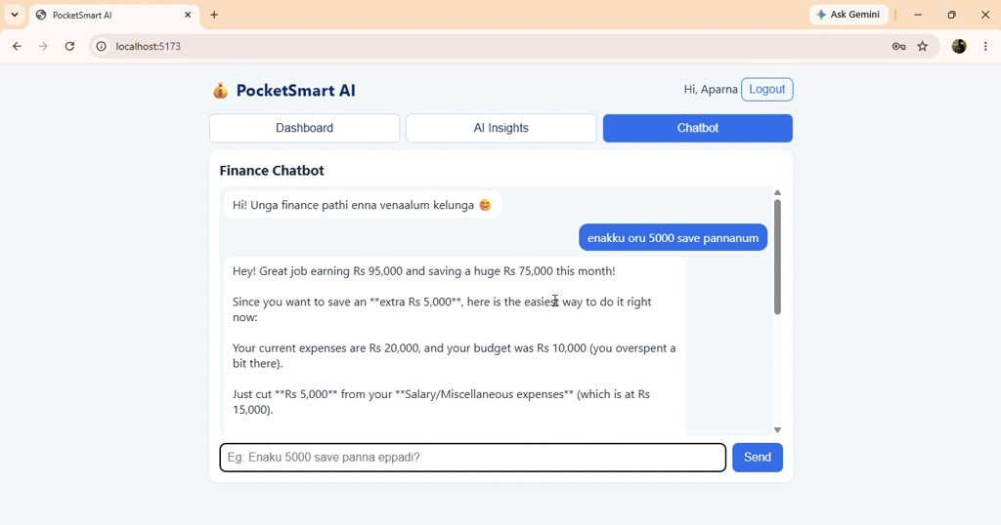
The browser evidence confirms the dashboard, AI Insights, and Chatbot flows.
The terminal evidence confirms the local backend and frontend development workflow.

Category totals help the user identify the largest spending area.
Budget progress makes monthly spending easier to understand.

